Hour | Topic & Subtopic | Relevance to Industry / Interview Preparation
1 | Introduction to System Design- High- level vs Low-level Design- Components of scalable systems- Examples: Gmail, Instagram, etc. | Struggling with LLD 𝐢𝐧 𝐈𝐧𝐭𝐞𝐫𝐯𝐢𝐞𝐰𝐬  Helps students articulate system behavior. Interviewers often start with “How would you design XYZ?”. Sets foundation for next sessions.  𝐇𝐨𝐰 𝐭𝐨 𝐀𝐩𝐩𝐫𝐨𝐚𝐜𝐡 𝐋𝐋𝐃 𝐏𝐫𝐨𝐛𝐥𝐞𝐦𝐬 𝐢𝐧 𝐈𝐧𝐭𝐞𝐫𝐯𝐢𝐞𝐰𝐬:  understanding the trade-offs.  SQL vs NoSQL  Normalization vs Denormalization  CAP Theorem IN Distributed Systems  Consistency Types  Batch vs Stream Processing  API Vs SDK!  Polling Vs Webhooks  Cache Related  Key Design Patterns  How Caches go wrong
2 | Client-Server System Design, Foundation of Design approaches  OOSD for Object Oriented applications with SOLID principles | Request-Response Lifecycle: From DNS lookup ➡ TCP handshake ➡ request ➡ response — To understand every step behind a simple button click.  System design thinkers shall fail if thet can’t address simple interview questions on SOLID.
3 | System Design: Scaling, Load Balancing & High Availability  Vertical vs Horizontal Scaling for App development.  How load balancing plays key role in Cloud platforms like AWS/AZURE/GCP | Scaling out (horizontal) /Scaling In(Vertical) is how companies like Netflix and Google handle millions of users daily.  Load Balancing: Distributing traffic across servers is an art:  ‣ Round Robin  ‣ Least Connections  ‣ IP Hashing
4 | System Design: Reliability, CAP Theorem & Distributed Tradeoffs  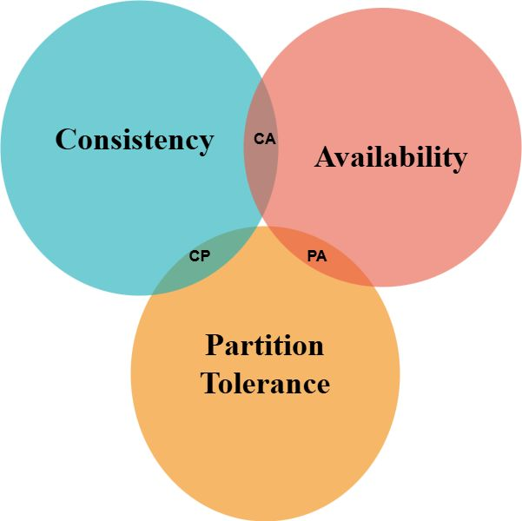 | Reliability vs Fault Tolerance  Heartbeats & Health Checks  CAP Theorem  ACID vs BASE
5 | System Design: Caching, Rate Limiting & Backpressur | Key for performance questions in  interviews. “How to reduce latency?”  is common.  Key strategy to reduce latency related questions
6 | System Design: Partitioning, Replication, Consistency | Interview questions concern with how large systems break data into pieces, keep it safe, and manage consistency.
7 | API Design: REST, gRPC, and GraphQL | Key questions related to design and selection of communication protocols - critical for scalable and efficient systems
8 | Architectural Patterns & Design Strategies | Interview questions concern about blueprints and design patterns behind scalable Systems. Like Microservices vs SOA  CQRS (Command Query Responsibility Segregation)  DDD (Domain-Driven Design)
9 | Key-Value, Object & Time-Series Storage | Participants shall have key performance aspects to address questions related to Redis, Memcached, S3, GCS, Influx DB, TimescaleDB
10 | Queue & Stream Processing  Batch vs Stream | How streaming and queuing performed in large scale systems like cloud and big data analytical systems
11 | Scaling Databases & Data Warehousing  scaling and analysis.  Database Scaling  Read Replicas  Federation splits | System Design wrt DB scaling preparation with various tips and techniques to address db level system design questions in interviews.
12 | All Above Design Best Practiices with interview-oriented case study based considering all practices for system design. | Consolidates all learned topics. Gives students confidence in discussing real- life problems in system design interviews by addressing questions like Why systems fail (and how to build ones that don’t).  Designing under constraints  latency, consistency, memory, user experience.  How trade-offs are everything.  From load balancing to Kafka-based event systems, from JWT-based security to design patterns like CQRS and DDD

